

COURSEWORK 1 (ASSIGNMENT)

Programme
DIPLOMA IN COMPUTER SCIENCE
Subject Code  DDS1323 | Subject Name  PROGRAMMING FOR DATA SCIENCE
Study Period  JAN 2026 – MARCH 2026 | Deadline  13/03/26 (Week 6)

Student ID | Student Name

Course Learning Outcomes
CLO 2 | Explain code conventions, the OOP codes concepts, language idioms and professional programming practice. (C2, PLO2)
CLO 3 | Practice some of the more commonly used standard library functions using object-oriented solution for simple programming problem to reduce programming effort. (P3, PLO3)

SDS ACADEMIC INTEGRITY STATEMENT

Sunway Diploma Studies is committed to the principles of academic integrity. Academic integrity means placing five fundamental values: honesty, trust, fairness, respect, and responsibility into practice. It is being honest in the academic work you do at the programme/college, being fair to others, and taking responsibility for learning, and acting in an ethical manner in all your academic endeavours. We believe that these five values are truly foundational to the programme.

We hereby declare that:
- We fully understand and will uphold the academic integrity of Sunway Diploma Studies (SDS).
- We confirm that the work hereby submitted is our own original work and where other people’s work has been used this has been fully acknowledged.
- We are aware of the importance of conducting exams with integrity and fairness, and We hereby confirm that We will comply with the requirements.
- We are aware that non-compliance with these instructions and unfair conduct constitute a disciplinary offense, and actions will be taken including but not limited to being expelled.

No | Student Name | Signature | Date
1
2
3
4
5

Group Member Contribution Form

INSTRUCTION
This assignment will contribute 50% to your final grade.
This is a group assignment (ONLY THREE TO FOUR students in a group).

Please fill in the form completely and ensure all group members sign it. A deduction of 3 marks will be applied to the total marks if the group fails to comply with this requirement.

Student Name | Signature | Contribution (eg. Coding, Design, Testing, Documentation, Question 1, etc)
Example: JOHN |  | Example:  - Write coding for Data cleaning  - Write Coding for ETL  - Write Introduction in Report

ASSSIGNMENT QUESTION

The Assignment consist of TWO (2) phases which is Data Analysis Phase/ Data Mining (Refer Practical 6a) and Prediction Phase (Refer Practical 6b). Students are required to analyse the data and mine the data using the dataset. Students are required to select a business field or any organization which they are familiar with and are interested in. Next, you need to identify the use of data as an appropriate application of data analytics tools in the chosen organization.

For Data Analysis Phase / Data Mining, students are encouraged to conduct descriptive and other statistical data analysis using the data analysis tools taught in the class to evaluate and answer the relevant questions. The project should cover a wide range of contents discussed in the lecture. Students are required to explain each step of the Data Analysis Process below:
- Business understanding
- Data Preparation/ Data Understanding
- Data Exploration (EDA)
- Train and Test

For Prediction Phase, students are encouraged to apply the appropriate machine learning (data mining) algorithms which can be supervised learning models or unsupervised learning models using the data mining tools taught in the class to evaluate and answer the relevant questions. The project should cover a wide range of contents Prediction Phase steps discussed in the lecture such as below:
- Modelling
- Deployments

Students are required to submit a FULL report for these two (2) phases that outlines a strategic plan to perform data analysis, extraction, transform, modelling and prediction results. It includes the processes/pre-processing steps and utilize data available to help making better decisions. Student must prepare TWO different datasets with same column name.

Prepare a report according to the attached report format to assess and examine the following requirements/ sections:

Report Content
- Introduction
  - Write about Company history and background.
  - Nature of business / size of business / type of organization / nature of competitiveness / culture / structures / etc.
  - Write TWO (2) objectives of the prediction project

Phase 1: Data Analysis and Data Mining (Refer to Data Analysis Proces

s (6a) steps)
- You may use your own datasets (Raw Dataset) OR you may use the dataset provided by your lecturer. Run your dataset with proper process of Data Cleaning, Data Analysis, Shows the selection of features using Chi-Square Test and p-value. Your training for regression model accuracy should be above 0.70 (R² value). Complete your training model and save your model in .sav format.

- For your report, make sure to screen shot every part of coding and explain in detail each process with the output of your codes. All explanations must justify your analysis and understanding of your coding process.

Example of justification:
- Four features were selected as independent variables versus target variables. The p-value shows that Mileage features influence the Price features of the Used car with p-value as 0.987.

- Every extract, transform and load the data files into the data analysis tool for this phase must be described in detail.

- Phase 2: Prediction (Refer to Prediction Process (6b) steps)
- Using the second dataset (New Dataset), proceed for prediction using the model generated in phase 1 (.sav). (You can provide questions and answer it accordingly to show the flow of the process; you may refer to the sample below).

- The new dataset shows that the predicted price are near accurate using the generated training model in phase 1.

- Every extract, transform and load the data files into the prediction phase must be described in detail.

- Each group is required to make an evaluation of the assignment he / she embarked on. The assignment evaluation may include:
- Evaluation of assignment (Each Student must write their own evaluations)
  - Students’ view on the strengths and weaknesses of the work done.
- Personal reflection (Each Student must write their own reflections)
  - Students are required to describe the various problems faced by students in the course of doing the assignment and explain what has been done to solve the problems, the valuable experiences gained or lessons learnt through the assignment as a whole.

- References.
- Appendix.
Submit the following document as part of the assignment.
- The TWO samples dataset file (.xlsx / .csv) (Raw and New)
- The Python Notebook file for both 6a & 6b reflects your dataset coding.
- The Modelling file (.sav)
- The detail assignment report.

Mode of Submission
- The assignment only can be submitted by ONE (1) representative per group.
- The assignment must be submitted in soft copy (report and source code).
- The report must use Times New Roman, 12 pt standard, alignment Justify, and 1.5 lines spacing.

Date of Submission
Dateline for submission is on (06/03/2026) WEEK 5 before 5.00 pm. As a general rule, no extension of time will be allowed.

Marking Rubric / Marking Scheme

The assessment of this final assignment report is based on the following criteria:
Criteria | Exceeds Requirements (Marks) | Meets Minimum Requirements (Marks) | Requires Revision to Meet Requirements (Marks)
Format (8%) | - Professional and consistent formatting throughout. Content is logically arranged and easy to follow. Appropriate academic/ report structure is fully applied. (7–8) | - Clear and recognizable format. Logical structure is generally applied but may lack consistency. (5–6) | - Little or no attempt to use appropriate formatting or structure. Content organization is unclear. (0–4)
Part 1: Introduction & Part 5: Conclusion (20%) | - Clear and comprehensive company background. Introduction and conclusion are logically connected and directly address the question. Conclusion effectively summarizes key findings. (16–20) | - Introduction and conclusion are present but contain some ambiguity. Connection to the question is partial. (10–15) | - Very brief or missing introduction and/or conclusion. Content is weakly related or unrelated to the question.  (0–9)
Part 2: Data Selection Process (13%) | - Correct and complete identification of the business case. Appropriate data is selected and clearly described. Strong justification for data selection. (10–13) | - Business case and data are identified with adequate description. Justification is present but limited.  (6–9) | - Poor or unclear identification of business case and data. Minimal or no justification provided. (0–5)
Part 3: Data Preparation Process (13%) | - Clear, logical, and reasonable data preparation process. Assessment and justification are well explained. (10–13) | - Data preparation process is described but lacks depth in explanation or justification. (6–9) | - Data preparation process is unclear or poorly justified. Limited explanation provided. (0–5)
Part 4: Data Analysis (13%) | - Clear and reasonable analysis with detailed evaluation. Explanations are well supported by evidence. (10–13) | - Analysis is reasonable but some explanations are unclear or incomplete. (6–9) | - Limited or weak analysis with minimal explanation. Evaluation is insufficient. (0–5)
Part 6: Data Mining (13%) | - Clear and logical data mining evaluation. Detailed explanations and interpretation of results. (10–13) | - Data mining evaluation is present but explanations lack clarity. (6–9) | - Poor or no data mining evaluation provided. Explanations are missing. (0–5)
Subject Knowledge (5%) | - Demonstrates strong understanding of taught concepts. Content is accurate and relevant. (4–5) | - Demonstrates basic understanding of taught concepts. (2–3) | - Shows little or no understanding of subject content. (0–1)
Originality (5%) | - Evidence of original work supported by appropriate research. (4–5) | - Some evidence of originality is present. (2–3) | - No evidence of originality. (0–1)
Individual Assessment: Personal Critical Reflection (10%) | - Clear, well-structured, and reflective discussion. Demonstrates strong critical thinking. (9–10) | - Reflection is structured but lacks depth in critical analysis. (5–8) | - Reflection is unclear, poorly structured, or missing. (0–4)

Individual Assessment (Personal Evaluation & Critical Reflection)

Individual Group Member Name | Personal evaluation & critical reflection (10%)  Completeness in describing the lessons and the knowledge that each of the student have learned. Evaluation on the critical thought of the student on the possible ethical and social issues that may raise up using such IS/IT to a chosen organization.
 | 0 – 2 | 3 – 4 | 5 - 8 | 9 - 10
 | Unable to provide clear and structured personal reflection content | Poor to provide clear and structured personal reflection content | Average in providing clear and structured personal reflection content | Excel and adequate in providing clear and structured personal reflection content
1.
2.
3.
4.
5.

Table of Contents

Introduction
- Company History & Background .......................................................... 12
- Nature of Business .................................................................................. 12
- Size of Business ....................................................................................... 12
- Type of Organization .............................................................................. 12
- Nature of Competitiveness ..................................................................... 12
- Culture & Structure ................................................................................. 12
- Objectives of the Prediction Project ..................................................... 13
Phase 1 : Data Analysis and Data Mining
- Objective ................................................................................................... 14
- Data Preparation ...................................................................................... 14
- Data Preparation ...................................................................................... 18
- Train and Test .......................................................................................... 24
Phase 2 : Prediction
- Section: Modelling and Deployment ..................................................... 28
- Evaluation ................................................................................................. 30
Evaluation of Assignment ........................................................................ 31
Personal Reflection .................................................................................... 31 References ................................................................................................... 32 Appendix ..................................................................................................... 33

Introduction

Company History & Background
Gem.Co specialises in the full diamond supply chain, from procurement to production and distribution. Founded in 1967, the company started as a humble diamond mine on the outskirts of Kimberley, South Africa and through the tutelage of the glorious founder Sir Gemry Gefferson, has grown to become the largest end-to-end diamond company in the world. In 2016, the company gained the largest share in the diamond market and to this day remains the largest company within the luxury gem space.

Nature of Business
Gem.Co specialises in the entire diamond supply chain, with mines in strategic locations across the globe. Gem.Co produces diamonds for both luxury and industrial purposes, selling directly to both types of consumers. Gem.Co operates in all markets globally, with the exception of North Korea and Australia.

Size of Business
Gem.Co employs 15,000 people worldwide and operates 120 mines across the globe, producing 60 million carats of diamonds per annum.

Type of Organization
Gem.Co is a privately held corporation structured as a limited liability company (LLC), with majority ownership retained by the Gefferson Foundation.

Nature of Competitiveness
The diamond industry is a highly competitive and volatile industry, with major players such as De Beers and Alrosa each vying for market share. Gem.Co differentiates itself by ethically sourcing, producing and pricing its products through the usage of highly intelligent artificial intelligence programs, allowing the company to provide the best products at the best price possible.

Culture & Structure
Gem.Co is committed to ethical and sustainable diamond production and works to ensure that its environmental impact is as close to zero as possible. As of 2024, the company has achieved its goal of net zero carbon emissions. Gem.Co follows a divisional structure, with each section of the supply chain operating individually.

Objectives of the Prediction Project

Gem.Co prides itself on pricing its products fairly. To ensure that the price of each diamond is fair and accurate, Gem.Co has developed a predictive model with the following objectives:

- To build a predictive model that estimates the price of a diamond based on its physical characteristics.
- To apply the trained predictive model onto a new diamond dataset to validate and confirm the accuracy of the predicted diamond prices.

Phase 1 : Data Analysis and Data Mining

Objective:
To build a predictive model that estimates the price of a diamond based on its physical characteristics.

Data Preparation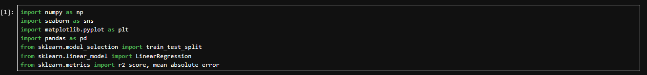
(Cell : 1)
Python libraries were imported for the project.
- NumPy for numerical operations such as log transformations.
- Pandas for data frame loading, creation and manipulation
- seaborn for generating boxplots
- matplotlib for rendering and displaying the other plots
- scikit-learn
  - test_train_split : for splitting the data into training and testing sets
  - LinearRegression : the algorithm model used to build the predictive model
  - r2_score and mean_absolute_error : to evaluate the model accuracy
These libraries were imported as they provide all the necessary functionality to properly build a prediction model

(2)
Dataset ‘DiamondPrices.csv’ was loaded into a DataFrame.
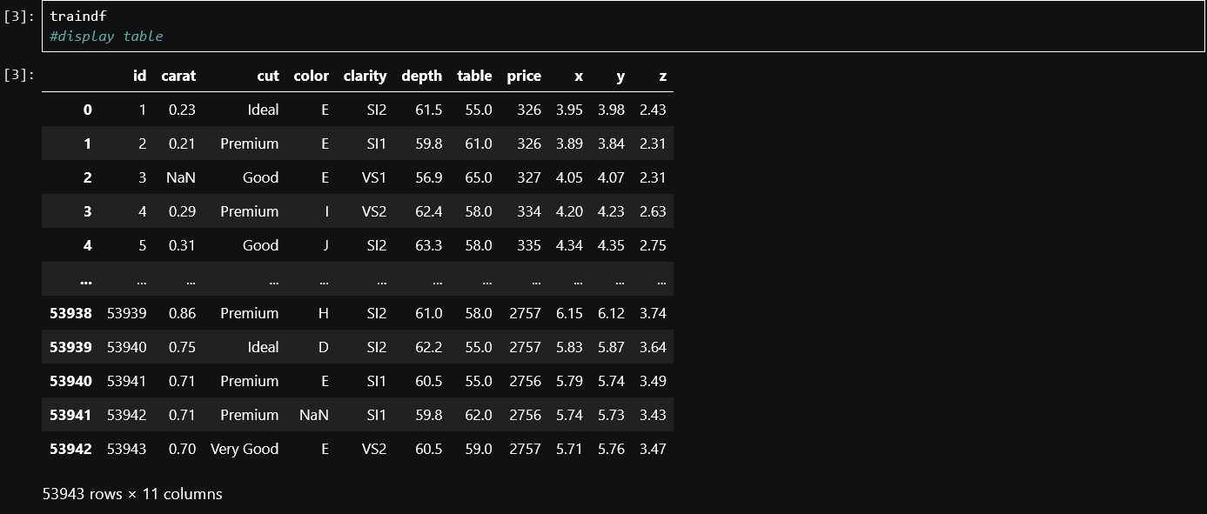
(3)
The DataFrame was displayed to inspect its contents.
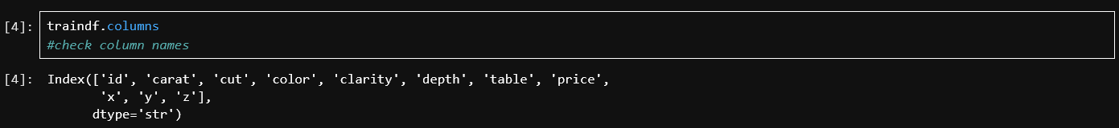
(4)
The names of the columns of the DataFrame were listed
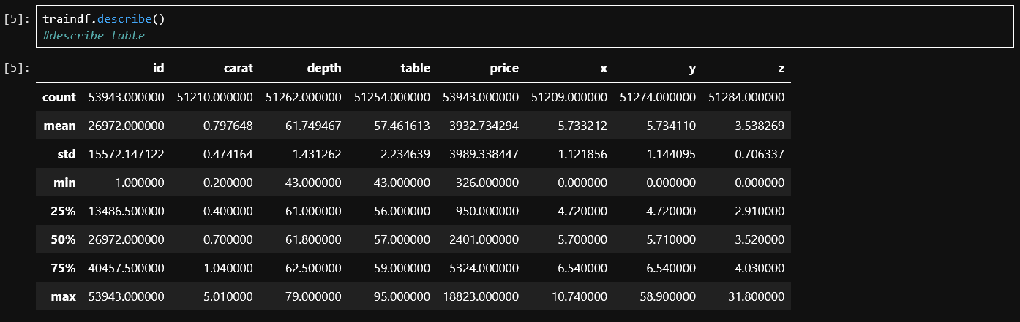
(5)
The descriptive statistics of the DataFrame were listed. It can be observed that
- count varies across columns , indicating that there are null values
- the minimum values of x,y and z contain 0 ,which is an impossibility
- the mean and median comparison shows that show columns are skewed

Descriptive statistics provide a numerical summary that shows us hints about potential actions we have to take to clean the data.
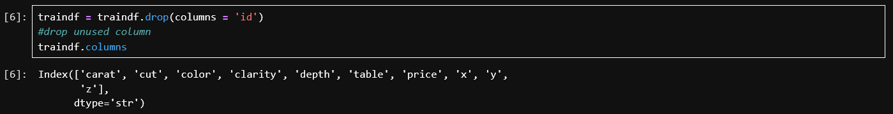
(6)
The ‘id’ column was dropped as it contains row identifiers for indexing purposes only, which serve no relevant purpose to the prediction model. Including this data would risk introducing noise to the model, resulting in accuracy loss. Removing irrelevant features is a standard data cleaning step to prevent irrelevant data from influencing the model
(7)
Rows where ‘x’, ‘y’ and ‘z’ were 0 were removed since they represent the length, width and height of a diamond, and physically cannot be 0. They represent data entry errors or unmeasured diamonds, and their inclusion would only serve to distort statistical calculations and mislead the model. This step also removed rows where ‘x’, ‘y’ and ‘z’ were null. Cleaning the physically impossible values ensured that the model reflects real-world diamonds and does not get misled into thinking that a diamond without a dimension exists at a certain price point
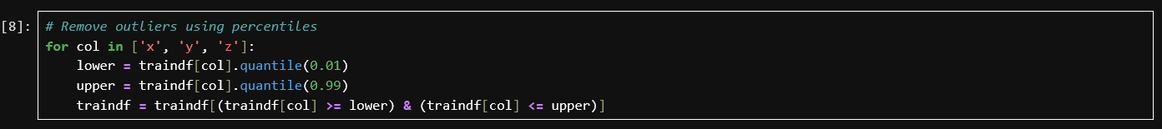
(8)
The outliers in the ‘x’ , ‘y’ and ‘z’ column were removed using percentile-based rules in which values lower than the 1st percentile or higher than the 99th percentile were removed. This removed the extreme values from each dimension column which were highly unlikely and did not represent the general diamond population, and would have led to the regression model’s coefficients being disproportionately influenced. Percentile-based removal is a robust outlier handling method as it balances the removal of data with minimal data loss
(9)
Duplicate rows were removed since they can incorrectly increase the weightage of values, leading to biased coefficient estimates. Removing duplicates ensures each value is represented exactly once , ensuring weightage is equal across the dataset to prevent the artificial inflation of patterns.
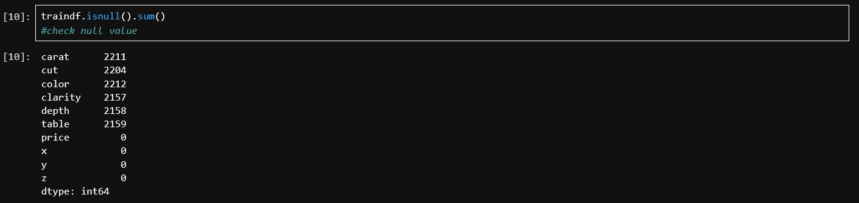
(10)
The sum of null values was checked. The null values of x, y and z had already been handled
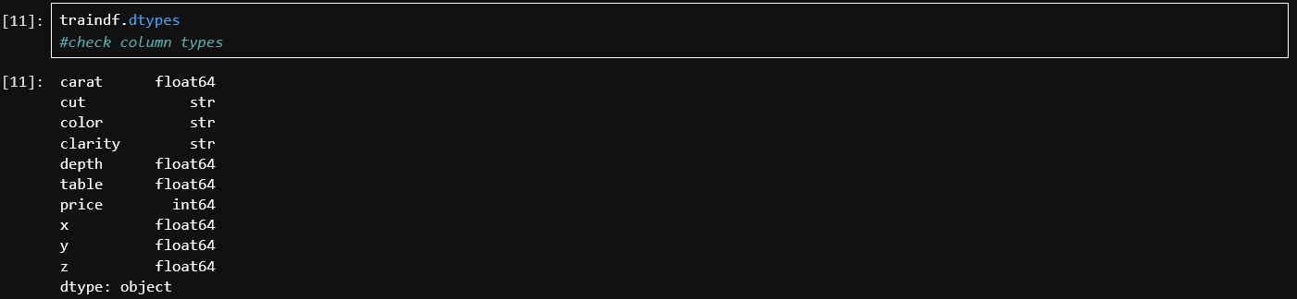
(11)
The data type of each column was displayed. Linear regression requires numerical inputs, therefore the string columns had to be either encoded as categorical values or removed.
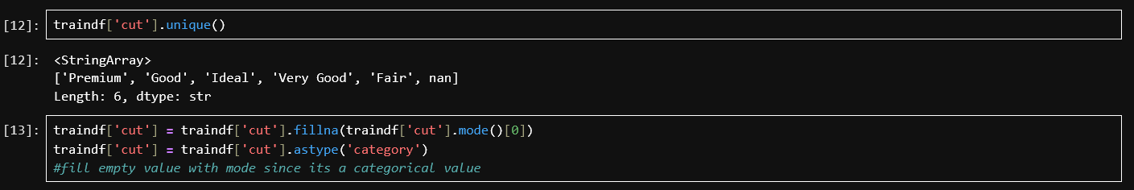
(12,13)
The unique values of ‘cut’ contained 6 different values, which means that it could be encoded as categorical values. Missing data were filled using the mode since it is the most appropriate imputation method for categorical data, as it replaces missing values with the most common value, preserving the overall distribution. The column was then cast into the categorical data type.
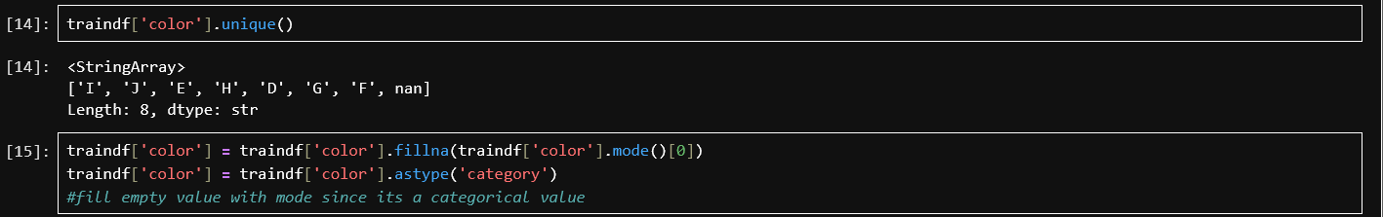
(15,16)
Following the logic of cells 12 and 13 , the null values of ‘Color’ are filled with the mode and the column is casted into categorical data.
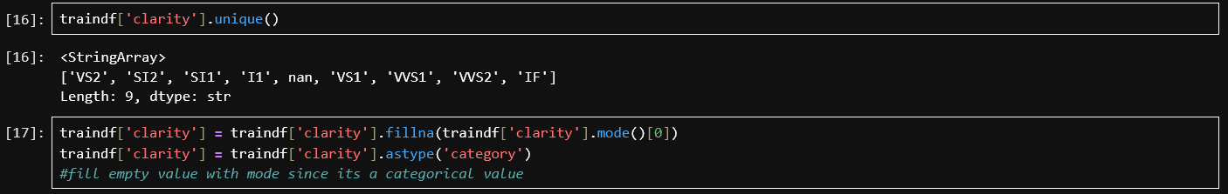
(16,17)
Following the logic of cells 12,13,14 and 15 , the null values of ‘Clarity’ are filled with the mode and the column is casted into categorical data.
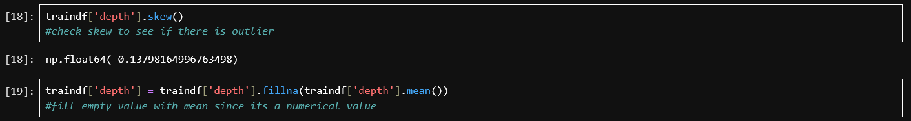
(18,19)
The skew of ‘depth’ was checked to ensure a normal distribution. Since it lay between -0.5 and 0.5, the data was approximately symmetrically distributed. Therefore, the null values were filled with the mean as it is the most suitable imputation value, as it represents the central tendency without being pulled by the skew.
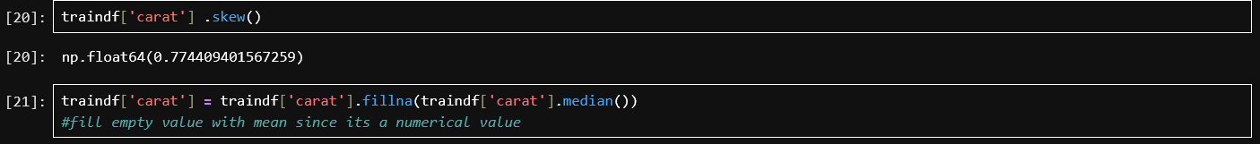
(20, 21)
The skew of ‘carat’ was checked and was approximately 0.774, which is larger than 0.5. The null values were filled with the median since the distribution was skewed and the median is resistant to outliers, in this case representing the central tendency better

Data Preparation
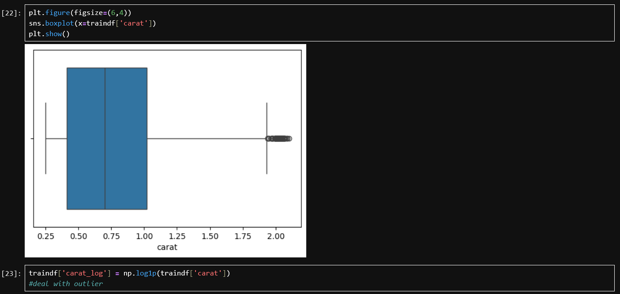
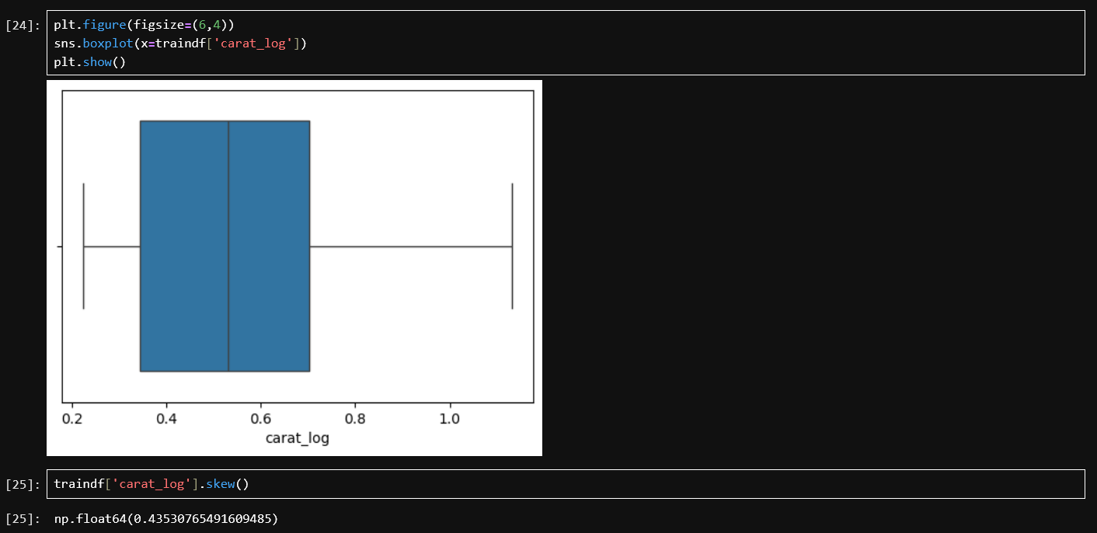
(22,23,24,25)
The box plot of ‘carat’ was generated and a right skew was observed, confirming the non-normally distributed data. To address this, the log1p transformation was applied to the column and the values were stored in a new column ‘carat_log’. The transformation compressed larger values and distributed smaller values more evenly, making the distribution more symmetrical. The skew of ‘carat_log’ was checked and found to be approximately 0.097, confirming the log transformation successfully normalised the distribution. Linear regression assumes the relationship between features and target is approximately linear, and heavily skewed data can lead to biased and inaccurate predictions.

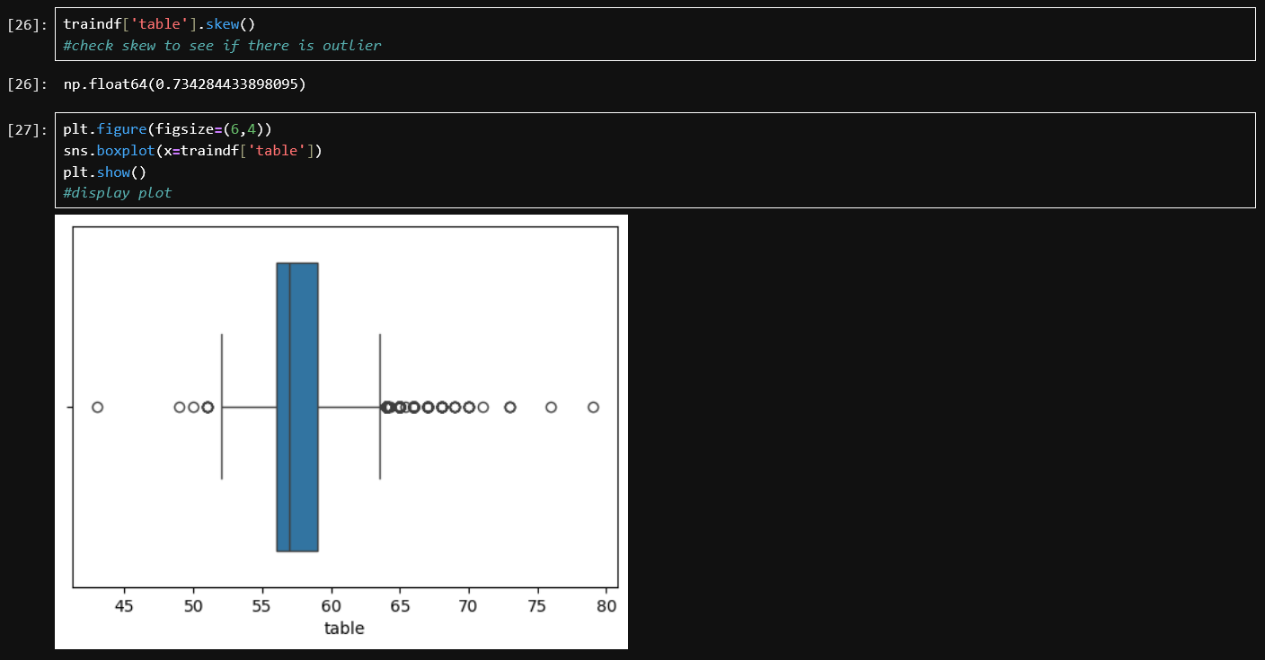
(26,27)
Following the logic of cells 20 and 21, the null values were filled with the median.
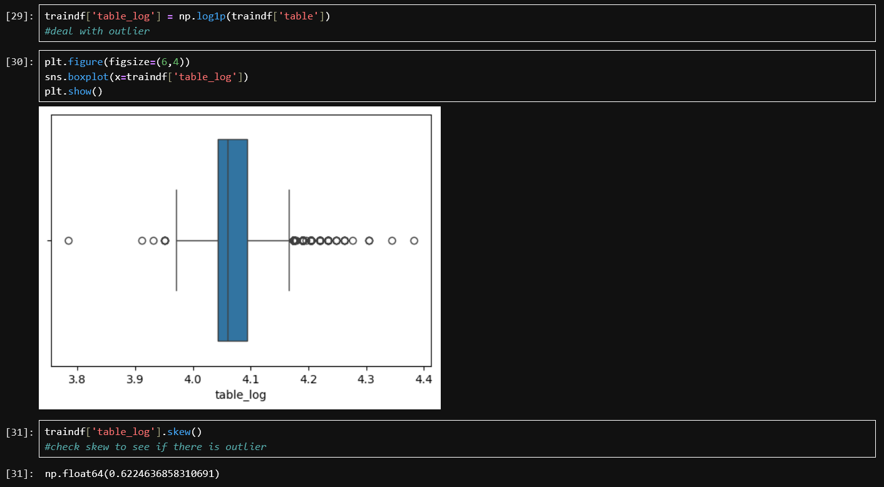
(29,30,31)
Following the logic of cells 22, 23, 24 and 25, the log1p transformation was applied to the column and the values were stored in a new column ‘table_log’. The skew was found to be 0.62, which is still larger than 0.5 but is an improvement over the original skew of 0.73, thus the ‘table_log’ column was kept.
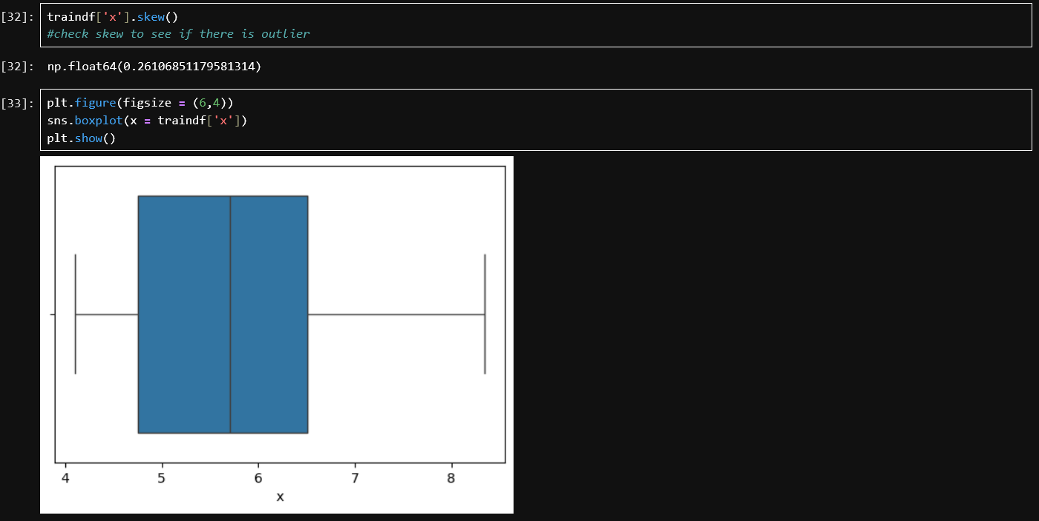
(32,33)
The skewness of ‘x’ was checked and since it was less than 0.5, no transformation was needed for ‘x’.
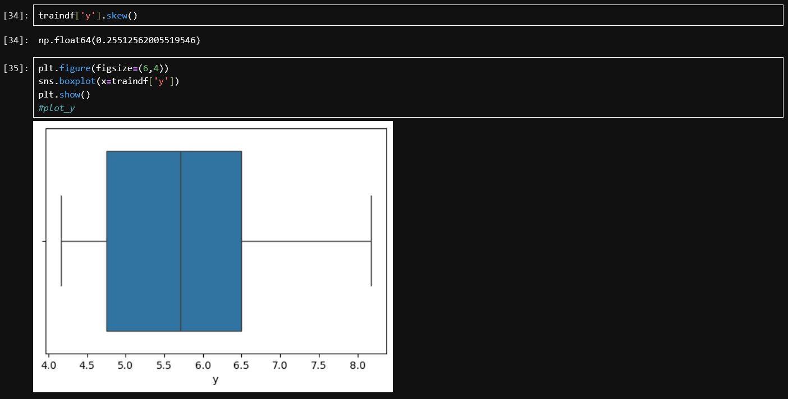
(34,35)
Following the same logic as cells 32 and 33, no transformation was necessary
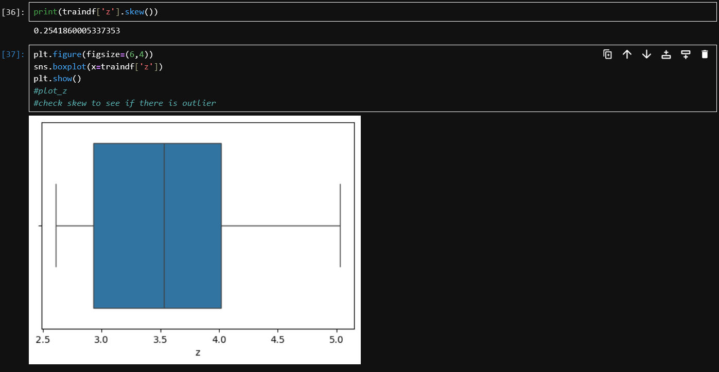
(36,37)
Following the same logic as the cells containing the other dimensions, no transformation was necessary

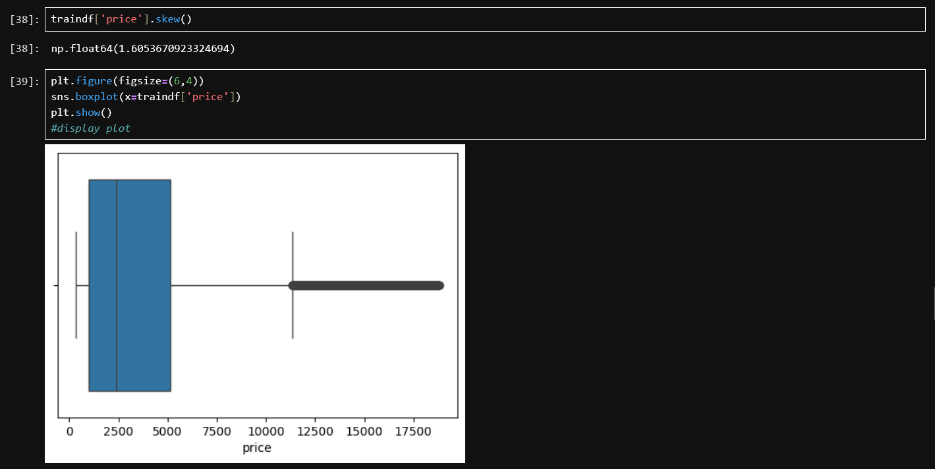
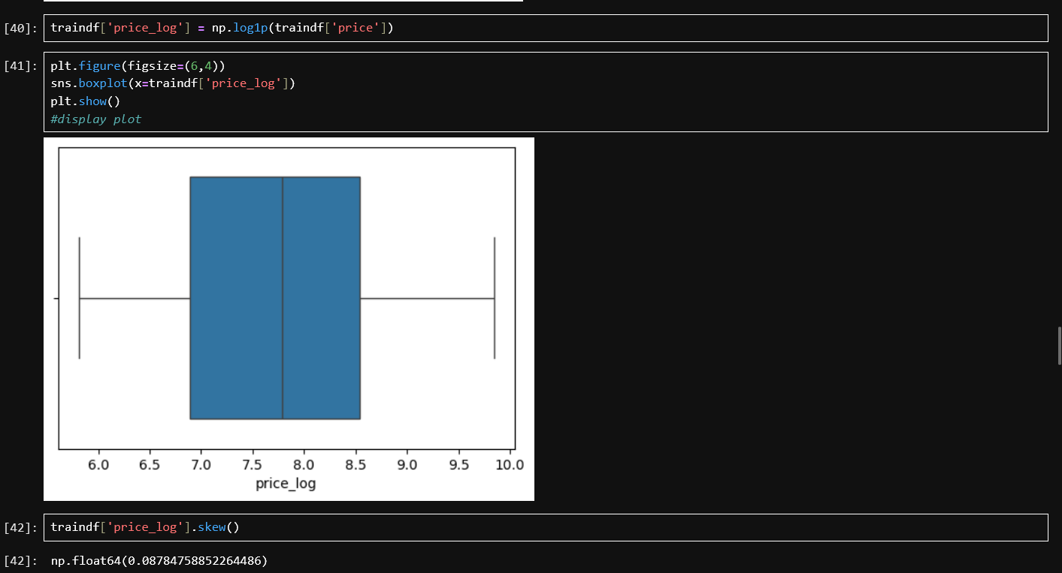
(38,39,40,41,42)
The skewness of price was calculated to be 1.60, indicating a strong positive skew. The box plot showed that the majority of diamond prices were concentrated at the lower end, while a long tail of outliers extended toward the higher values. The column was transformed using the log1p transformation and the values were stored in ‘price_log’. The skew after the transformation was 0.08, and the box plot showed a more symmetrical distribution. Predicting ‘price_log’ instead of ‘price’ is critical to ensure that the model does not disproportionately fixate on higher values, which would lead to inaccurate predictions.

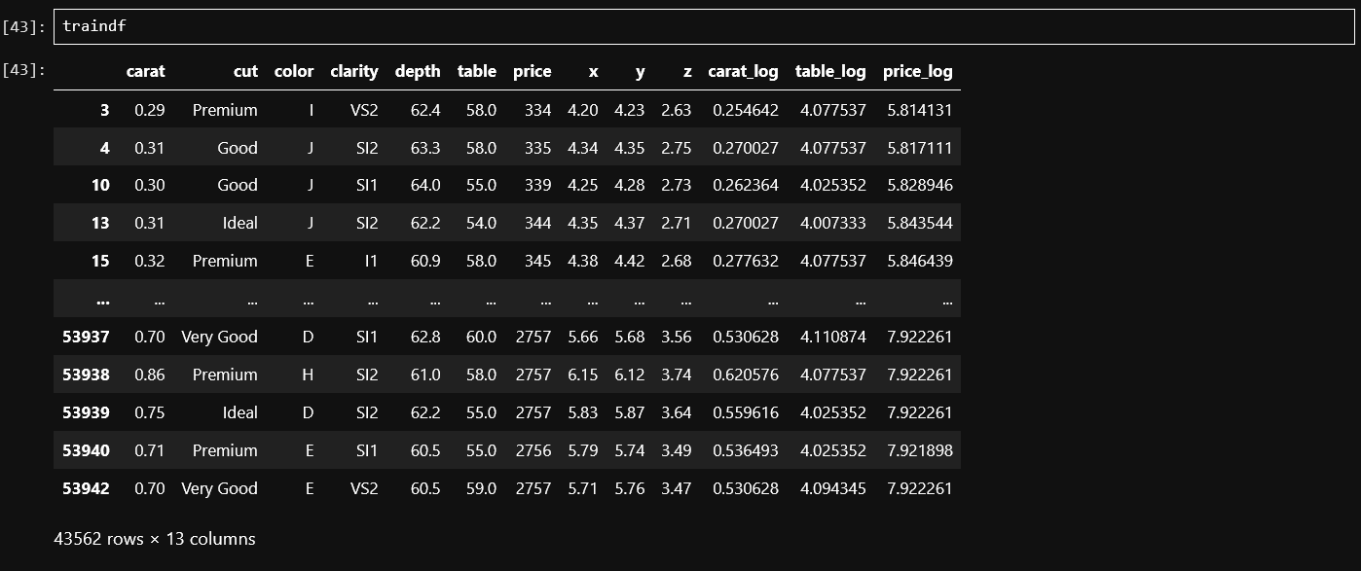
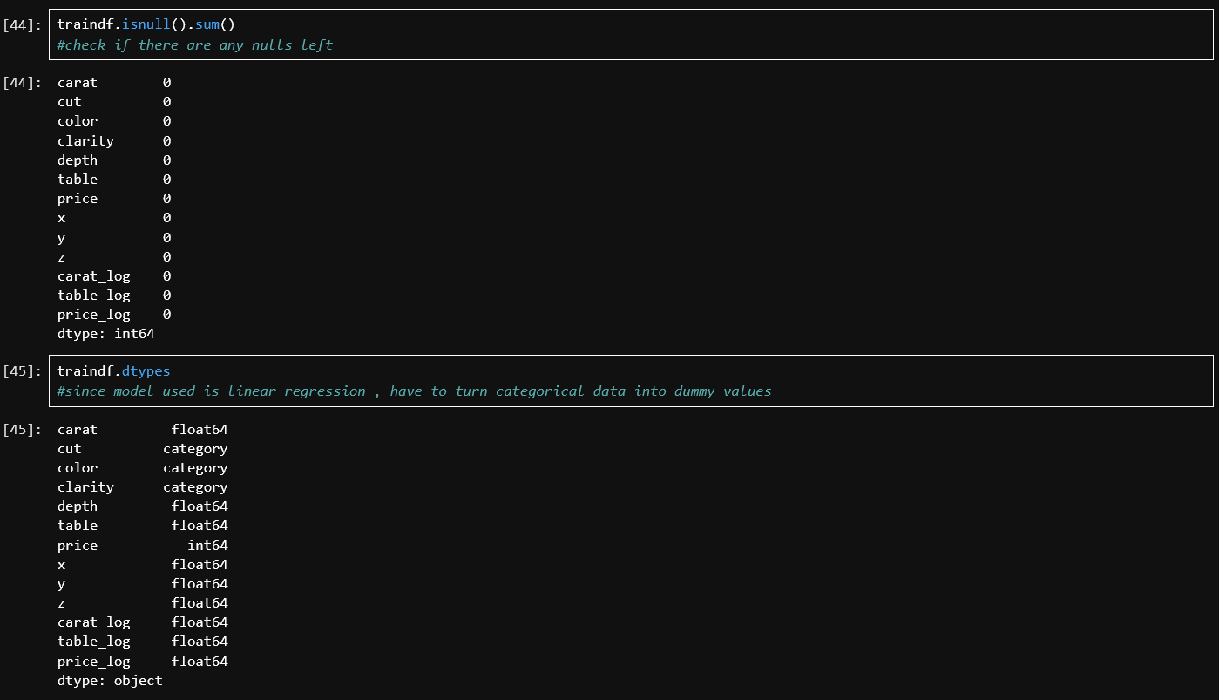
(43,44,45)
The final verification of the DataFrame before training was conducted. Displaying the full DataFrame visually verified that all transformations and imputations had been applied correctly and that the new ‘log’ columns were included within the DataFrame. The null check confirmed that the DataFrame had no missing values, and the data types were checked to ensure that linear regression could use the data.

Train and Test
(46)
The categorical columns were converted into dummy variables, which are binary columns, to ensure that linear regression could properly utilise the values. Dummy encoding creates a new binary column for each unique value within the categorical column. The first category was dropped to prevent multicollinearity, which occurs when two or more independent variables in a regression model are highly correlated with each other, making it difficult for the model to determine the individual effect of each variable. The dummy variables were assigned to a new DataFrame
(47)
The numerical features that would be used in the training data were added to the DataFrame
(48)
The DataFrame containing the dummy variables and the numerical variables were concatenated horizontally.
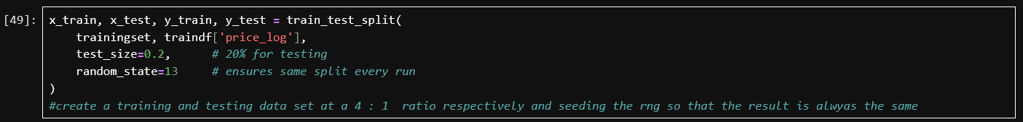
(49)
The training dataset was split into 80% training and 20% testing data, with the random split seeded to ensure that the same split is produced every time the code is run, ensuring reproducibility. The target variable was ‘price_log’. ‘x_train’ and ‘y_train’ were used to fit the model, while ‘x_test’ and ‘y_test’ were used to evaluate it.
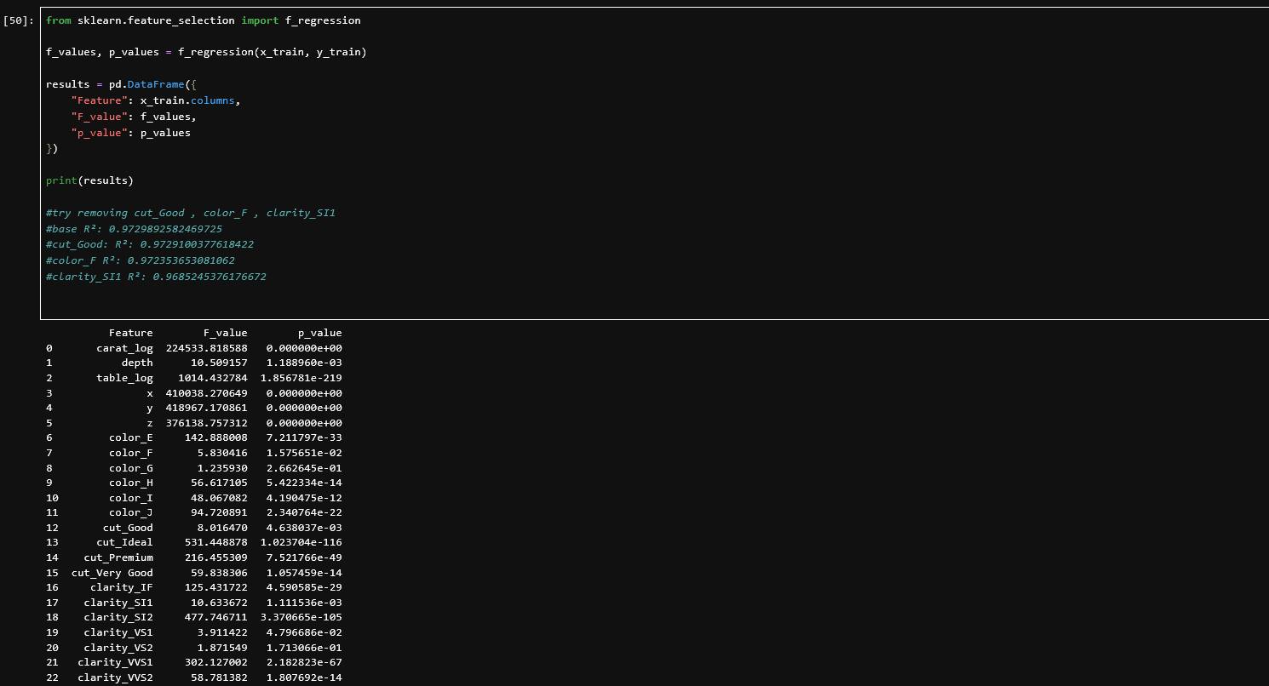
(50)
The f_regression function was used to evaluate the strength of the linear relationship between each individual feature and the target variable. It produces an f-statistic, in which a higher value indicates a stronger linear relationship with the target, and a p-value, in which a higher value indicates a higher probability that the observed relationship occurred by chance. The features ‘cut_Good’, ‘color_F’ and ‘clarity_SI1’ were all identified as potentially problematic values, but after comparing the R² value before and after their removal, they justified their inclusion as removing them reduced the R² value. Feature selection prevents overfitting by eliminating noise produced by features that do not have a meaningful linear relationship with the target
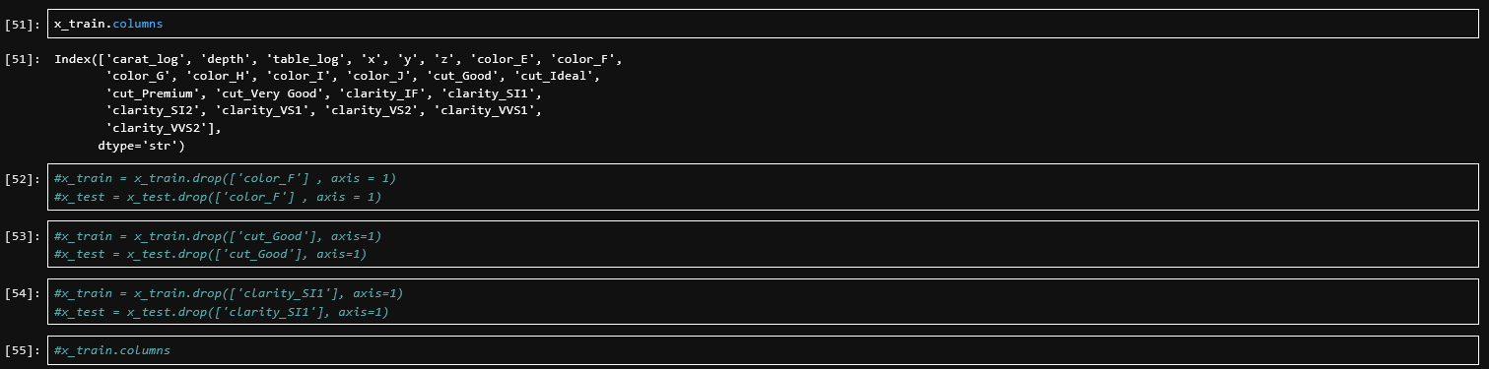
(51,52,53,54,55)
As stated in cell 50, each feature suspected of reducing the model’s performance was tested. All 23 features were retained, as they all contribute to the accuracy of the model

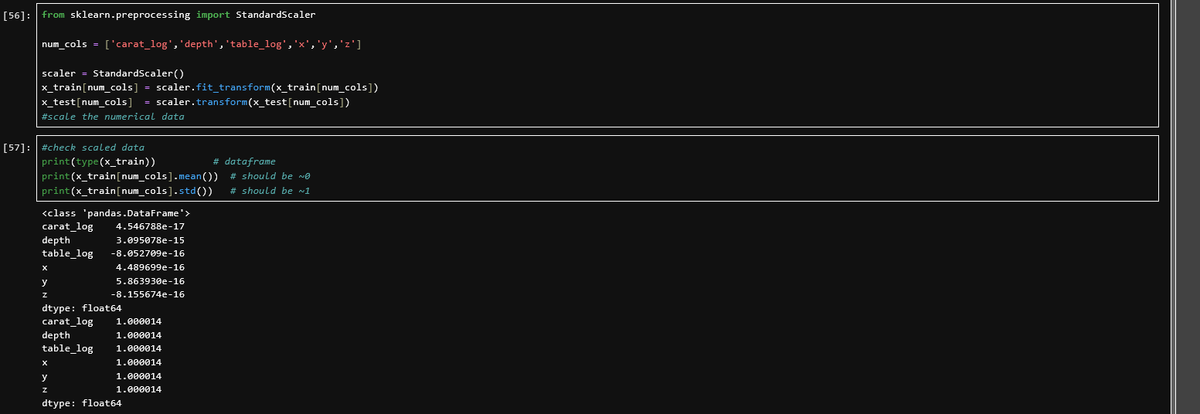 (56,57)
StandardScaler was applied to each numerical column, transforming each feature to have a mean of approximately 0 and a standard deviation of approximately 1. The scaler was fit on the training data to calculate the mean and standard deviation only from the training data, and then applied to the test data using the same parameters without recalculating them, preventing data leakage. The verification showed that the scaling was successful, as each feature had a mean of approximately 0 and a standard deviation of approximately 1. Scaling ensures that features with large numerical ranges do not dominate the model; without scaling, the regression coefficients would reflect the scale of each feature rather than its true importance.
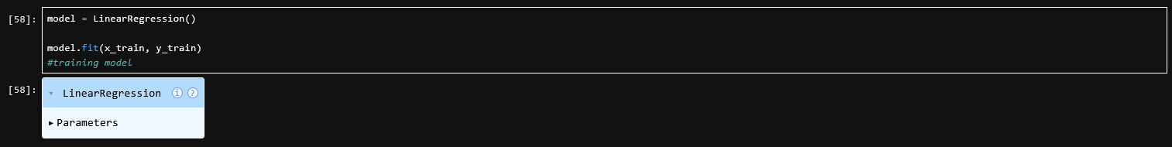
(58)
The linear regression model was trained on the scaled features and dummy variables with ‘price_log’ as its target
(60)
The model was used to generate predictions on the test set, which were stored in a new DataFrame.

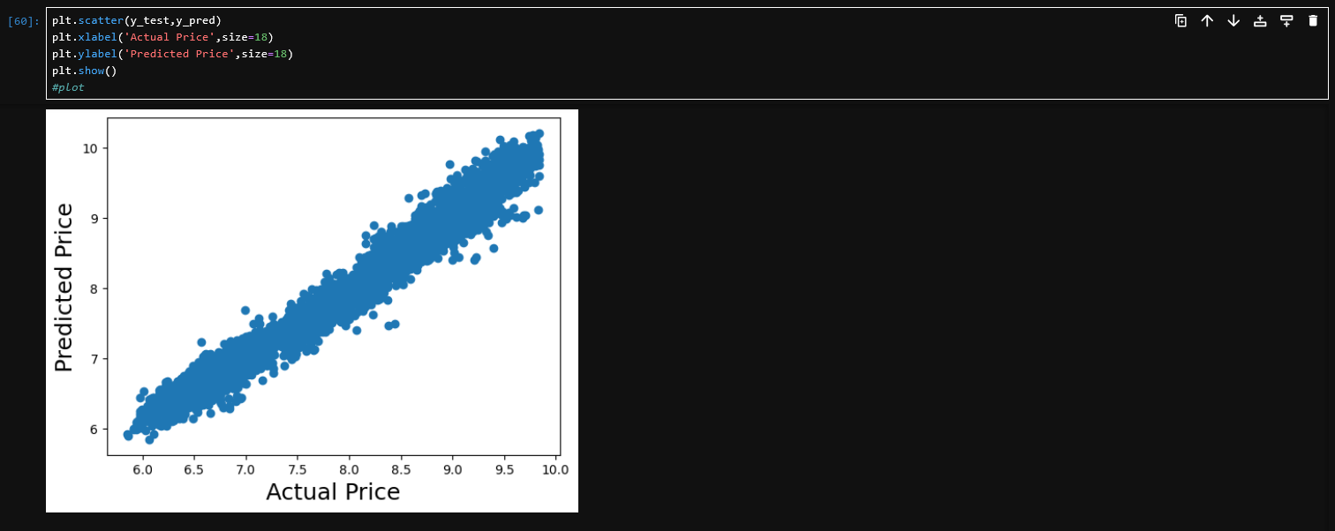
(60)
A scatter plot of the actual values of ‘price_log’ against the predicted values of ‘price_log’ was plotted. The plot showed that the points clustered tightly around the diagonal, indicating strong predictive performance. Scatter plots help visually evaluate the accuracy of a model.
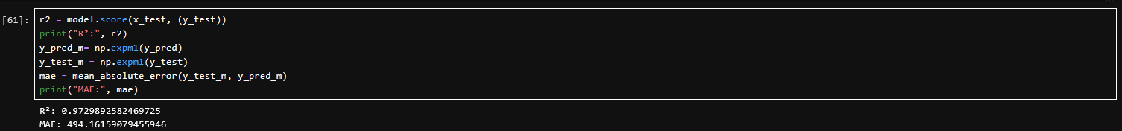
(61)
The accuracy of the model is evaluated using
- R² (R-squared) = 0.9730 : The model explains approximately 97.30% of the variance in log-price. An R² of 1.0 would mean perfect prediction, while 0.0 would mean the model is no better than simply predicting the average.
- MAE (Mean Absolute Error) = 494: represents the average absolute difference between the predicted and actual prices after converting back from the log scale. With a target mean of approximately 3,933, this indicates the model's predictions are off by roughly 12.6% which is considered a good range.
(62)
The trained model and fitted scaler were saved to be used in Phase 2.

Phase 2 : Prediction

Section: Modelling and Deployment

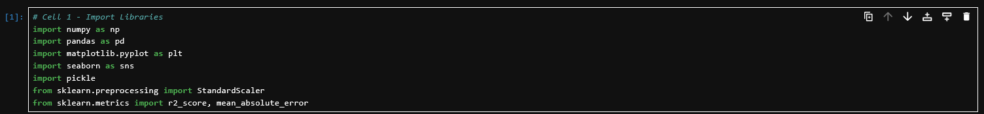
(1)
The same libraries as in Phase 1 were imported
(2)
The model and scaler from Phase 1 were imported.
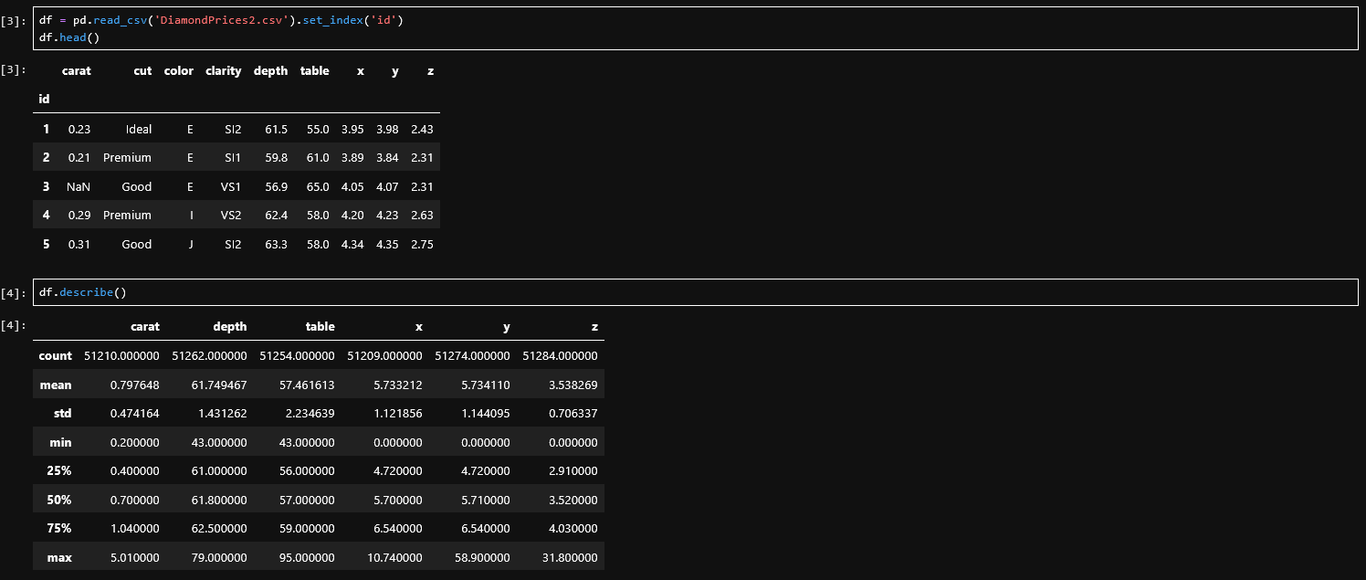
(3,4,5)
The new dataset was loaded and inspected. The dataset had the same structure as the dataset used in Phase 1, aside from an ‘id’ column being added and the ‘price’ column being removed.
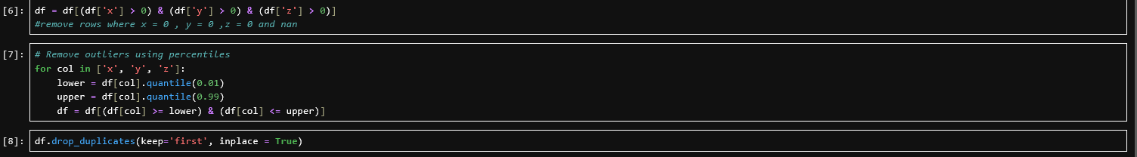
(6,7,8)
The data was cleaned using the same process as in Phase 1, where zero-dimensional data, percentile outliers, and duplicates were removed. The data underwent the same cleaning steps to ensure that the model received data of the same quality and format it was designed for.
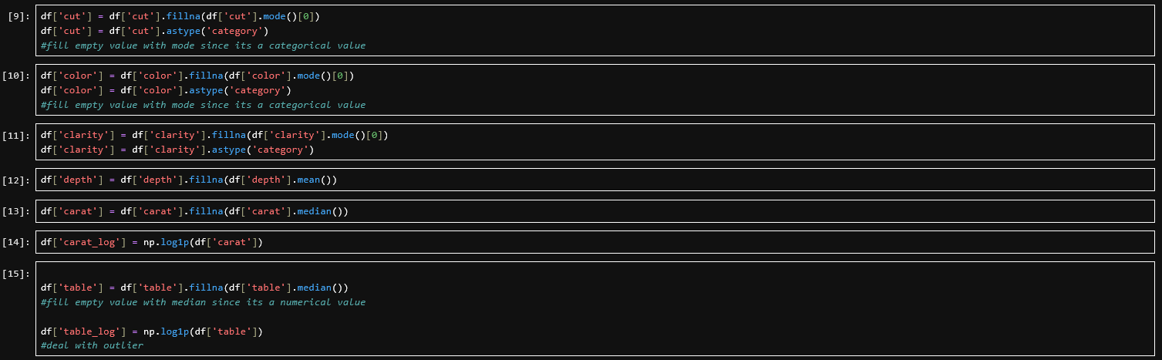
(9,10,11,12,13,14,15)
The missing values were imputed and outliers addressed using the same strategies as in Phase 1. The imputation values were calculated from the new dataset to ensure that the null values were filled with the best available estimates. The values that were log-transformed in Phase 1 were also log-transformed to ensure that the model’s predictions would be accurate, as it was trained on log-transformed features.
(16)
The categorical columns were converted into dummy variables
(17,18)
The numerical columns were scaled using the scaler imported from Phase 1 to ensure that the mean and standard deviation the model was scaled on remained the same. The scaler had to use the training data's statistics since the model's coefficients were trained to that specific scaling. Using different statistics would manipulate features differently, causing the model to misinterpret feature values and produce inaccurate predictions.
(19,20,)
The model’s expected feature names were extracted. The scaled values and dummy variables were concatenated and reindexed to ensure that the new dataset’s columns aligned with the columns the model expected. Any columns present in the new dataset but not expected by the model were dropped.
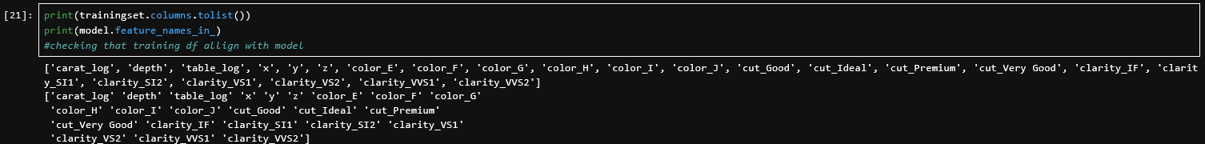
(21)
The training dataset's columns and the model's expected feature names matched, confirming that the new dataset had been correctly aligned with the model's expectations, enabling the model to safely make predictions on the new data.
(22)
The model from Phase 1 was used to predict prices based on the new dataset. The predicted values were transformed from the log scale back to the original scale and stored in a new DataFrame.
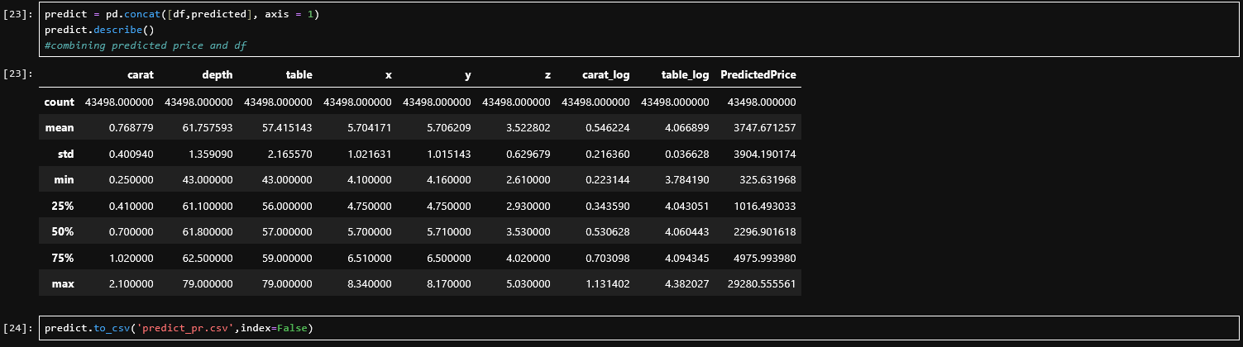
(23,24)
The original dataset was combined with the predicted prices and described to verify that the predicted prices were reasonable. The DataFrame was then exported for external use.

Evaluation

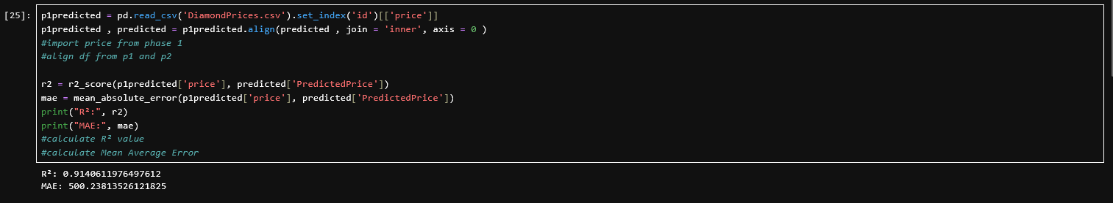
(25)
The accuracy of the model is evaluated using
- R² = 0.9141 — This means the model explains approximately 91.41% of the variance in price. An R² of 1.0 would mean perfect prediction, while 0.0 would mean the model is no better than simply predicting the average. A score of 0.9141 indicates an excellent fit.
- MAE = 500 — This is the average absolute difference between predicted and actual prices. With a mean diamond price of approximately 3,933, this indicates the model's predictions are off by roughly 12.7% on average, which is considered a good range

Evaluation of Assignment

For Strengths: I believe that a strength of my work is that the prediction model is accurate with an R² value of 0.97 and an MAE of ~13% of the mean target value for Phase 1 and an R² value of 0.92 and MAE of ~12.7% for Phase 2, which indicates that the Linear Regression model performed well. I also believe that the data was well prepared and cleaned, with null values filled with the appropriate assumption, impossible values and outliers removed, data types correctly cast and skewed values addressed. I ensured pipeline consistency between Phase 1 and Phase 2 by saving and reusing the scaler, and ensuring that the data cleaning process between the two datasets was identical, which prevented data leakage and ensured that the prediction model was as accurate as possible.

For Weaknesses: I am unsure if the model I have utilised is the best fit for the data given, linear regression does not handle outliers well so using another model that is more robust to outliers such as Ridge Regression or Gradient Boosting may have generated more accurate results. The outlier removal could have been more accurately done using another method such as IQR or Z-Score threshold instead of percentile, which may have increased the accuracy of the model. I also did not follow proper naming conventions and code readability, which could lead to some confusion when trying to read the code.

Personal Reflection

This was a fun project, and at the same time I feel as if I have just climbed Mount Stupid of the Dunning-Kruger effect. Every slight error took longer than I would like to admit to solve. But at the same time, I will admit that I had fun writing the code for this project. Working with a language that I have had no prior experience with was tough, but pushing through was rewarding. I believe that I now have a better understanding of how machine learning works and what I have to do to improve upon this project .

References

Alaswad, N. (n.d.). Diamonds prices [Dataset]. Kaggle. https://www.kaggle.com/datasets/nancyalaswad90/diamonds-prices
ALROSA. (2024). Market share of the leading diamond mining companies worldwide in 2023 [Graph]. Statista. https://www.statista.com/statistics/585450/market-share-of-diamond-supply-worldwide-by-producer/
Matplotlib. (n.d.). Matplotlib API reference. https://matplotlib.org/stable/api
NumPy. (n.d.). NumPy reference. https://numpy.org/doc/2.4/reference/index.html
Pandas. (n.d.). Pandas API reference. https://pandas.pydata.org/pandas-docs/stable/reference/index.html
Scikit-learn. (n.d.). Scikit-learn API reference. https://scikit-learn.org/stable/api/index.html
Seaborn. (n.d.). Seaborn tutorial. https://seaborn.pydata.org/tutorial
Wan Othman, W. S. N. A. (2025). Lesson 6a: Build prediction model [Jupyter notebook]. Google Colab. https://colab.research.google.com/drive/1BU2byoluW6ysNLXNljpn4GFj4Ib_92bV?usp=sharing
Wan Othman, W. S. N. A. (2025). Lesson 6b: Apply save model with new dataset [Jupyter notebook]. Google Colab. https://colab.research.google.com/drive/1wA7I9NMvSophMsdP0X4iNZ_OenN_x8Tn?usp=sharing

Appendix

